CSA 1016 SOFTWARE ENGINEERING
Medication Adherence Tracker for Elderly Patients with Caregiver Alerts
Assessment Task 1
Scenario-Based Requirement Analysis — CO2,
Domain: Healthcare / HealthTech (Assistive & Remote-Care Systems)
Name:Alima Banu R-192471044

1. Introduction

1.1 Purpose
This Software Requirement Specification (SRS) defines the functional and non-functional requirements for the Medication Adherence Tracker ("MedTrack"), a system designed to help elderly patients take prescribed medication on schedule and to keep caregivers informed when a dose is missed. The document is intended to guide design, development, testing, and acceptance of the system, and to serve as the agreed contract of scope between stakeholders and the development team.

1.2 Intended Audience
- Development team (analysts, designers, developers, testers)
- Project stakeholders and sponsors (course evaluator / product owner)
- Elderly patients and their caregivers (end users)
- Healthcare partners — doctors, pharmacists, care facilities

1.3 Document Conventions
Functional requirements are prefixed FR-, non-functional requirements NFR-, use cases UC-, and data entities DE-. "Shall" denotes a mandatory requirement; "should" denotes a desirable but non-mandatory requirement. Priority is expressed as High / Medium / Low, reflecting impact on patient safety and core adherence tracking.

1.4 References
- IEEE Std 830-1998 — Recommended Practice for Software Requirements Specifications
- Project Kanban board and backlog maintained in Jira (project key: MEDTRACK)
- General practice guidance on medication-adherence and remote patient-monitoring systems

2. Problem Description

2.1 Business Domain
MedTrack sits in the Healthcare / HealthTech domain, specifically the assistive and remote-patient-monitoring sub-domain that supports independent living for the elderly. It bridges consumer health apps and light-weight clinical workflows: patients and informal caregivers are the daily users, while doctors and pharmacists interact with the system at the edges of the care process.

2.2 Stakeholders
Stakeholder | Role / Interest | Priority
Elderly Patient | Primary user; takes medication, needs simple reminders and low cognitive load | High
Caregiver / Family Member | Monitors adherence remotely; needs timely, reliable alerts | High
Doctor / Physician | Prescribes and adjusts medication; reviews adherence trends | Medium
Pharmacist | Fulfils refill requests; verifies dosage and interactions | Medium
System Administrator | Manages accounts, system health, and configuration | Medium
Care Facility / NGO (secondary) | May deploy the system across many residents | Low

2.3 Existing Challenges
- Elderly patients frequently forget doses, take incorrect quantities, or lose track of complex multi-drug schedules.
- Paper charts and pill organisers give no real-time visibility to family members who live remotely.
- Missed doses are discovered late, sometimes only during the next clinical visit, increasing health risk (e.g. for cardiac, diabetic, or hypertensive patients).
- Caregivers lack a single, trustworthy channel for alerts and instead rely on phone calls or informal check-ins.
- Prescription changes made by a doctor are not automatically reflected in the patient's day-to-day reminder routine.
- Existing pill-reminder apps are largely single-user and do not model the caregiver relationship or escalation workflow.

2.4 System Objectives
- Provide simple, accessible medication reminders tailored to elderly users (large text, minimal steps, optional voice/IoT dispenser integration).
- Log every dose event (taken, skipped, delayed) to build an accurate adherence history.
- Notify one or more caregivers automatically when a dose is missed beyond a configurable grace period.
- Give doctors and pharmacists the visibility and workflow hooks they need (prescription updates, refill requests) without overloading the patient interface.
- Be reliable, private, and easy to maintain as new patients, medications, and caregivers are added.

3. Scope of the System

3.1 In Scope
- Patient registration, profile, and medication schedule management
- Configurable reminders (push notification, SMS, and optional smart-dispenser trigger)
- Dose confirmation (taken / skipped / delayed) by the patient or an IoT dispenser event
- Missed-dose detection and tiered caregiver alerting, including emergency escalation
- Caregiver dashboard showing adherence history and trends
- Doctor workflow for prescribing and updating medication; pharmacist workflow for refill requests
- Administrative functions: user management, audit logs, notification-gateway configuration
- Basic adherence reporting and export

3.2 Out of Scope (Version 1.0)
- Automated drug-interaction / clinical decision support (flagged as a future enhancement)
- Direct e-prescribing integration with national health-insurance systems
- Billing, insurance claims, or payment processing
- Video-consultation or telemedicine features
- Native hardware manufacturing of the smart pill dispenser (the system integrates with third-party dispensers via API only)

4. Functional Requirements
Functional requirements describe the observable behaviour the system must provide.
ID | Requirement | Priority
FR-01 | The system shall allow a patient (or an on-behalf caregiver) to register and create a profile. | High
FR-02 | The system shall allow patients/caregivers/doctors to log in securely using credentials or OTP. | High
FR-03 | The system shall allow a doctor or patient to add, edit, or discontinue a medication with dosage, frequency, and duration. | High
FR-04 | The system shall generate a daily reminder schedule automatically from active medication entries. | High
FR-05 | The system shall send reminders via push notification and/or SMS at the scheduled dose time. | High
FR-06 | The system shall allow the patient to mark a dose as Taken, Skipped, or Snoozed. | High
FR-07 | The system shall accept a dose-taken event from an integrated smart pill dispenser, where available. | Medium
FR-08 | The system shall detect a missed dose when no confirmation is received within a configurable grace period. | High
FR-09 | The system shall notify the linked caregiver(s) automatically when a dose is missed. | High
FR-10 | The system shall escalate to a secondary contact or emergency alert if the caregiver does not acknowledge within a configurable time window. | Medium
FR-11 | The system shall let a caregiver link to one or more patients, subject to patient/administrator approval. | High
FR-12 | The system shall let a caregiver view adherence history and trends for each linked patient. | High
FR-13 | The system shall let a caregiver configure alert rules (channel, grace period, quiet hours) per patient. | Medium
FR-14 | The system shall let a doctor review a patient's adherence report before adjusting a prescription. | Medium
FR-15 | The system shall let a patient or caregiver submit a refill request to a linked pharmacy. | Medium
FR-16 | The system shall let a pharmacist view and action refill requests. | Medium
FR-17 | The system shall let an administrator create, suspend, or delete user accounts and roles. | Medium
FR-18 | The system shall maintain an audit log of all dose events, alerts, and prescription changes. | Medium
FR-19 | The system shall allow export of adherence reports (e.g. PDF/CSV) for clinical visits. | Low
FR-20 | The system shall support multiple languages and large-text / high-contrast display modes for accessibility. | Medium

5. Non-Functional Requirements
Non-functional requirements constrain how the system performs its functions.
ID | Requirement | Category | Priority
NFR-01 | Reminder notifications shall be dispatched within 5 seconds of the scheduled time under normal load. | Performance | High
NFR-02 | The system shall support at least 50,000 concurrent patient profiles without degradation (horizontal scaling). | Scalability | Medium
NFR-03 | The system shall be available 99.5% of the time per month, excluding scheduled maintenance windows. | Availability | High
NFR-04 | All health data shall be encrypted in transit (TLS 1.2+) and at rest (AES-256). | Security | High
NFR-05 | The system shall comply with applicable health-data privacy regulation (e.g. HIPAA/GDPR-equivalent handling of PHI). | Security / Legal | High
NFR-06 | The patient-facing UI shall follow accessibility guidelines suited to elderly users (WCAG 2.1 AA, large tap targets, minimum 3 taps per core action). | Usability | High
NFR-07 | A missed critical-medication alert shall reach the caregiver with 99.9% delivery reliability, using a fallback channel (SMS) if push fails. | Reliability | High
NFR-08 | The codebase shall be modular (patient service, alert service, notification gateway) to ease independent maintenance and deployment. | Maintainability | Medium
NFR-09 | The system shall retain audit logs for a minimum of 3 years for regulatory traceability. | Compliance | Medium
NFR-10 | The system shall degrade gracefully (queue and retry) if the SMS/push gateway or smart-dispenser API is temporarily unavailable. | Reliability | Medium
NFR-11 | Average response time for dashboard queries shall not exceed 2 seconds for 95% of requests. | Performance | Medium
NFR-12 | The system shall support role-based access control so a caregiver can only see data for linked patients. | Security | High

6. Actors and Use Cases

6.1 Actor Summary
Actor | Type | Description
Elderly Patient | Primary | Registers, views reminders, confirms doses, requests refills, views own history.
Caregiver / Family Member | Primary | Links to a patient, receives missed-dose alerts, configures alert rules, views adherence reports.
Doctor | Primary | Prescribes/updates medication, reviews adherence history to inform treatment.
Pharmacist | Primary | Actions refill requests, verifies dosage information.
System Administrator | Primary | Manages accounts, roles, audit logs, and notification-gateway settings.
Notification Service (SMS/Push) | Secondary (external) | Delivers reminders and alerts on behalf of the system.
Smart Pill Dispenser (IoT) | Secondary (external) | Optionally reports dose-taken events automatically.
Pharmacy Information System | Secondary (external) | Receives and confirms refill requests.

6.2 Use Case Diagram
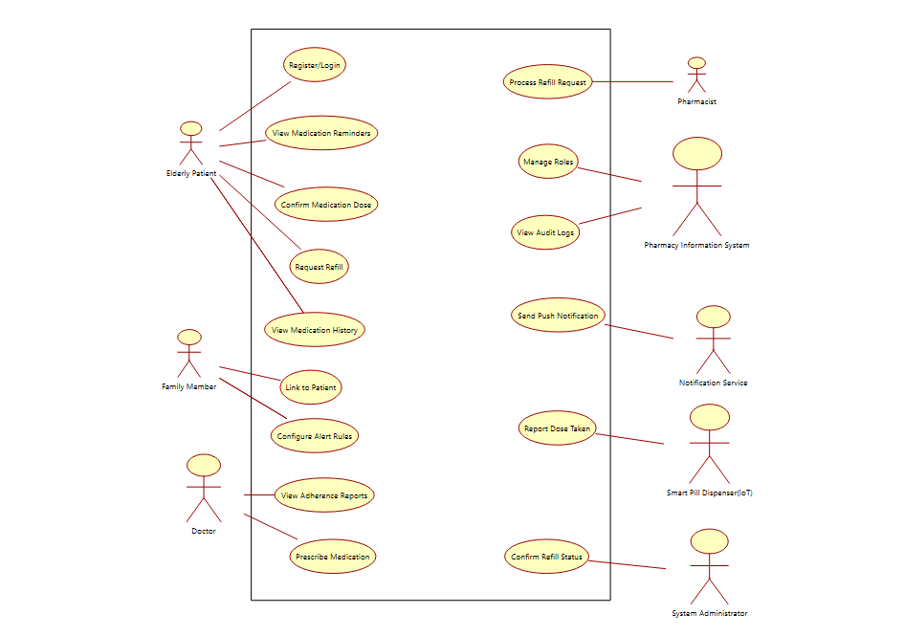

6.3 Use Case Inventory
ID | Use Case | Primary Actor
UC-01 | Register / Login | Patient / Caregiver / Doctor
UC-02 | Add / Edit Medication Schedule | Patient / Doctor
UC-03 | Configure Reminders | Patient
UC-04 | Mark Dose Taken / Skipped | Patient
UC-05 | Receive Missed-Dose Alert | Caregiver
UC-06 | Configure Caregiver Alert Rules | Caregiver
UC-07 | View Adherence Report | Patient / Caregiver / Doctor
UC-08 | Emergency Escalation | Caregiver / System
UC-09 | Prescribe / Update Medication | Doctor
UC-10 | Request Refill | Patient / Caregiver
UC-11 | Manage Patient-Caregiver Link | Caregiver / Administrator
UC-12 | Review Patient Adherence History | Doctor / Pharmacist
UC-13 | Manage User Accounts | System Administrator
UC-14 | Monitor System Logs / Audit | System Administrator
UC-15 | Configure Notification Gateway | System Administrator

7. Detailed Use Case Descriptions
Two representative use cases are elaborated below in full template form; the remaining use cases from Section 6.3 follow the same structure and are maintained as Jira user stories (see Section 11).

UC-04: Mark Dose Taken / Skipped
Actor(s) | Elderly Patient (primary), Smart Pill Dispenser (secondary)
Precondition | Patient is registered and has an active medication schedule; a reminder has been triggered.
Main Flow | 1. System sends a reminder. 2. Patient opens the reminder and taps "Taken" (or the dispenser reports a dispense event). 3. System timestamps and logs the dose event. 4. System updates the adherence record and cancels the pending missed-dose timer.
Alternate Flow | 3a. Patient taps "Snooze" — system re-reminds after a configurable interval. 3b. Patient taps "Skip" and optionally records a reason — system logs a skipped dose.
Exception Flow | No response before the grace period elapses → triggers UC-05 (Receive Missed-Dose Alert).
Postcondition | Dose event is recorded in the adherence log with status Taken, Skipped, or Missed.

UC-05: Receive Missed-Dose Alert
Actor(s) | Caregiver (primary), Notification Service (secondary)
Precondition | A dose reminder has not been confirmed within the configured grace period.
Main Flow | 1. System marks the dose as Missed. 2. System looks up the alert rules and linked caregiver(s) for the patient. 3. System sends an alert via the caregiver's preferred channel (push/SMS). 4. Caregiver acknowledges the alert in the app.
Alternate Flow | 3a. Preferred channel fails to deliver — system retries via fallback channel (SMS).
Exception Flow | No caregiver acknowledgement within the escalation window → triggers UC-08 (Emergency Escalation) to a secondary contact.
Postcondition | Caregiver is informed of the missed dose; the event is recorded in the audit log.

8. Data Requirements
The core data entities and representative attributes are summarised below; a full entity-relationship diagram and normalised schema would be produced during detailed design.
Entity | Key Attributes
Patient | patient_id, name, DOB, contact, address, primary_caregiver_id, accessibility_prefs
Caregiver | caregiver_id, name, contact, relationship, notification_prefs
Medication | medication_id, patient_id, name, dosage, frequency, start_date, end_date, prescribing_doctor_id
Schedule | schedule_id, medication_id, time_of_day, days_of_week, grace_period_minutes
Dose Log | dose_log_id, schedule_id, timestamp, status (Taken/Skipped/Missed), source (App/Dispenser)
Alert | alert_id, dose_log_id, caregiver_id, channel, sent_at, acknowledged_at, escalated (bool)
Doctor | doctor_id, name, license_no, contact, linked_patients
Pharmacist / Pharmacy | pharmacy_id, name, contact, linked_patients
Refill Request | request_id, patient_id, medication_id, requested_at, status, pharmacy_id
Audit Log | log_id, actor_id, action, entity, timestamp

8.1 Data Retention & Privacy
- Dose logs and audit logs are retained for a minimum of 3 years (NFR-09).
- Personally identifiable and health data is treated as sensitive (PHI) and access-controlled by role (NFR-12).
- Patients may request export or deletion of their data subject to applicable regulation and any active clinical record-keeping obligations.

9. External Interface Requirements

9.1 User Interfaces
- Patient mobile/web app: large-text, high-contrast, minimal-step reminder and confirmation screens.
- Caregiver dashboard (mobile/web): adherence trends, alert center, alert-rule configuration.
- Doctor/Pharmacist portal (web): prescription management, adherence review, refill queue.
- Administrator console (web): user/role management, audit log viewer, gateway configuration.

9.2 Hardware Interfaces
- Optional integration with third-party smart pill dispensers via a documented REST/IoT API to receive dose-dispensed events.

9.3 Software Interfaces
- Push notification provider (e.g. FCM/APNs) and SMS gateway for reminders and alerts.
- Pharmacy information system API for refill request submission and status updates.
- Requirement and project-management tooling: Jira is used to record epics, user stories (mapped 1:1 to the use cases in Section 6.3), acceptance criteria, and sprint status, giving end-to-end traceability from SRS requirement ID to delivered feature (see Section 11).

9.4 Communication Interfaces
- All client-server communication over HTTPS/TLS 1.2+.
- Webhook-based callbacks from the notification gateway and dispenser API for delivery/dispense confirmation.

10. System Features
Feature | Description | Priority
Smart Reminders | Auto-generated, configurable reminders per medication, with snooze and multi-channel delivery. | High
Dose Confirmation | One-tap confirmation from the app or automatic confirmation from a smart dispenser. | High
Caregiver Alerting & Escalation | Tiered alerts to primary and secondary contacts when a dose is missed. | High
Adherence Analytics | Trends, streaks, and missed-dose statistics for patients, caregivers, and doctors. | Medium
Prescription Management | Doctor-driven medication add/update workflow that automatically reshapes the reminder schedule. | Medium
Refill Workflow | Request, track, and fulfil medication refills with a linked pharmacy. | Medium
Accessibility Mode | Large text, high contrast, and voice-assist options tailored to elderly users. | Medium
Administration & Audit | Role-based user management and a tamper-evident audit trail. | Medium

11. Requirement Management Tool — Jira
Per course guidance, Jira is used as the real-time requirement and project-tracking tool for this analysis. A note on the artefacts below: the board and tickets shown here are an illustrative, to-scale mock-up of the recommended Jira layout — not a captured screenshot from a live Jira instance, since this document is produced outside Jira itself. To complete the submission, the project's Jira board should be set up as described below and the actual screenshots (board view, backlog, and one expanded ticket) pasted into this section before submission.

11.1 Suggested Jira Project Setup
- Project key: MEDTRACK, Project type: Team-managed Software (Scrum or Kanban).
- Epics: one per major capability — Reminders & Scheduling, Dose Logging, Caregiver Alerts, Prescription & Refill, Admin & Audit.
- Each Functional Requirement (FR-xx) and Use Case (UC-xx) in this SRS is entered as a Jira User Story, linked to its parent Epic, with the SRS ID placed in the story's summary or a custom "Requirement ID" field for traceability.
- Non-functional requirements are entered as Jira issues of type "Requirement"/"Task" and linked to the stories they constrain (e.g. NFR-01 linked to the Reminders epic).
- Labels such as safety-critical, caregiver-facing, and admin help filter the backlog.

11.2 Illustrative Board Layout

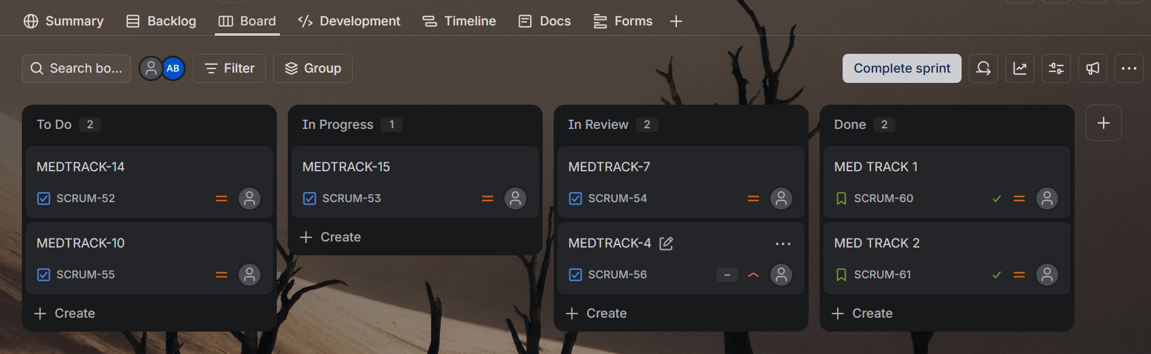

11.3 Sample Backlog Mapped to Requirements
Jira Key | Story | Linked Requirement | Epic
MEDTRACK-4 | As a patient, I can register and log in securely | FR-01, FR-02 | Reminders & Scheduling
MEDTRACK-6 | As a doctor, I can add/edit a patient's medication schedule | FR-03, FR-04 | Reminders & Scheduling
MEDTRACK-7 | As a patient, I receive a push/SMS reminder at dose time | FR-05, NFR-01 | Reminders & Scheduling
MEDTRACK-9 | As a caregiver, I can configure alert rules for a patient | FR-13 | Caregiver Alerts
MEDTRACK-10 | As a caregiver, I am alerted when a dose is missed | FR-08, FR-09, NFR-07 | Caregiver Alerts
MEDTRACK-15 | As a patient, I can request a medication refill | FR-15, FR-16 | Prescription & Refill

11.4 What to Capture as Screenshots
- Board view showing the columns and populated cards for the current sprint/backlog.
- Backlog view showing epics with linked stories.
- One expanded story/ticket showing description, acceptance criteria, linked requirement ID, and status history.

12. Assumptions and Constraints

12.1 Assumptions
- Patients or a caregiver on their behalf have access to a smartphone or basic feature phone capable of receiving push notifications or SMS.
- At least one caregiver is willing and available to be linked to each patient for alerting purposes.
- Smart pill dispensers, where used, expose a documented API and are a value-add, not a mandatory dependency.
- Doctors and pharmacists already hold verified professional credentials managed by an external authority; the system trusts an existing verification/onboarding process.
- Internet/network connectivity is intermittently available; short offline periods are tolerated with local queuing.

12.2 Constraints
Type | Constraint
Technical | Must integrate with third-party push/SMS gateways and, optionally, third-party IoT dispenser APIs with varying reliability.
Operational | 24/7 alerting requires an on-call/monitoring process for the notification pipeline itself, not only the software.
Economic | Solution should favour low-cost or freemium notification channels to keep the system affordable for elderly/low-income users.
Legal / Regulatory | Must comply with applicable health-data privacy regulation (e.g. HIPAA/GDPR-equivalent) for storing and transmitting PHI.
Time | Academic project timeline limits the scope to the features listed in Section 3.1; advanced clinical decision support is deferred.
Usability | UI must remain usable for elderly users with potential vision, hearing, or dexterity limitations.

13. Requirement Validation — Completeness & Consistency

13.1 Stakeholder Coverage Check
Stakeholder | Requirements Addressing Them | Covered?
Patient | FR-01–08, FR-15, FR-19–20, NFR-06 | Yes
Caregiver | FR-09–13, NFR-07, NFR-12 | Yes
Doctor | FR-03, FR-14, UC-09, UC-12 | Yes
Pharmacist | FR-15–16, UC-10, UC-12 | Yes
Administrator | FR-17–18, UC-13–15 | Yes

13.2 Consistency & Ambiguity Checks Performed
- Verified no two functional requirements assign conflicting responsibility for the same action (e.g. only FR-08 defines missed-dose detection; FR-09/10 build on it rather than duplicating it).
- Checked that every use case referenced in Section 6.3 has a corresponding functional requirement (traceable) or is explicitly noted as administrative/support (UC-13–15 trace to FR-17–18).
- Replaced vague terms (e.g. "quickly", "most patients") with measurable criteria in the non-functional requirements (e.g. NFR-01: within 5 seconds; NFR-03: 99.5% availability).
- Confirmed no redundant requirements exist by cross-checking the FR and NFR tables against the Jira backlog mapping in Section .

